Number4

2024-02-23

# Sheikh-Sedat Touray

#QUESTION 4 `

## R Markdown

This is an R Markdown document to show my first log into the uri R studio. attaching dataset

attach(mtcars)  
head(mtcars)

## mpg cyl disp hp drat wt qsec vs am gear carb  
## Mazda RX4 21.0 6 160 110 3.90 2.620 16.46 0 1 4 4  
## Mazda RX4 Wag 21.0 6 160 110 3.90 2.875 17.02 0 1 4 4  
## Datsun 710 22.8 4 108 93 3.85 2.320 18.61 1 1 4 1  
## Hornet 4 Drive 21.4 6 258 110 3.08 3.215 19.44 1 0 3 1  
## Hornet Sportabout 18.7 8 360 175 3.15 3.440 17.02 0 0 3 2  
## Valiant 18.1 6 225 105 2.76 3.460 20.22 1 0 3 1

# Simple Scatterplot1

plot(wt, mpg, main="Scatterplot Example",  
 xlab="Car Weight ", ylab="Miles Per Gallon ", pch=19)

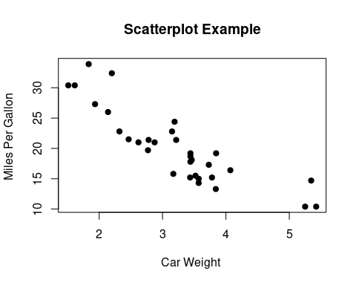

# Simple Scatterplot2

# Add fit lines  
plot(wt, mpg, main="Scatterplot Example",  
 xlab="Car Weight ", ylab="Miles Per Gallon ", pch=19)  
abline(lm(mpg~wt), col="red") # regression line (y~x)  
lines(lowess(wt,mpg), col="blue") # lowess line (x,y)

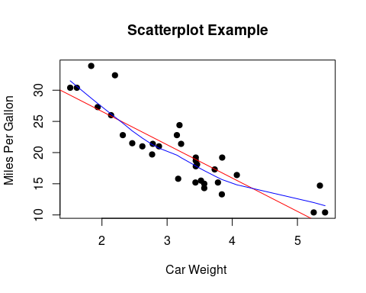

# Scatterplot3

# High Density Scatterplot with Binning  
library(hexbin)  
x <- rnorm(1000)  
y <- rnorm(1000)  
bin<-hexbin(x, y, xbins=50)  
  
plot(bin, main="Hexagonal Binning")

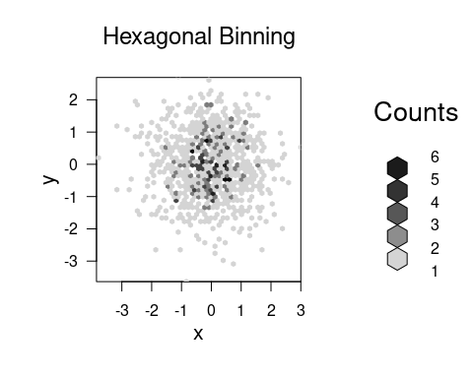

# Scatterplot4

# Basic Scatterplot Matrix  
pairs(~mpg+disp+drat+wt,data=mtcars,  
 main="Simple Scatterplot Matrix")

